**Noname manuscript No.**

(will be inserted by the editor)

**Bootstrapping for Fuzzy Mediation and Moderated-Mediation Analysis**

**Da Jeong Kang1,**†**· Hyeon Gu Kang1,**†**· and Jin Hee Yoon**2,*

Received: date / Accepted: date

**Abstract**

1 Department of Mathematics and Statistics, Sejong University, Seoul 05006, South Korea ; {doramisister, mjsk1145}@naver.com

**\***Correspondence: [jin9135@sejong.ac.kr](mailto:jin9135@sejong.ac.kr); Tel.: +82-10-9118-3135

**†** These two authors contributed equally to this work.

**Keywords:**

# 1 Introduction

When describing human behavior, social scientists and behavioral scientists hold that when people are exposed to particular stimuli, they do not instantly react but rather do so through internal organic body.  We have been curious in the process by which one phenomenon influences another because of this. By adding a third variable, they attempted to investigate the causal relationship between the independent and dependent variables and better comprehend their relationship, and it was discovered that the mediator and moderator components of this variable are separated.

A mediator variable is a variable that logically intervenes between independent and dependent variables in the causal relationship and is required to explain why or how.

For instance, client satisfaction will increase as a result of a company's satisfied products. In other words, consumers who are happy with the product will also be satisfied with the company; on the other hand, customers who are unhappy with the product will typically be less satisfied. The variable that describes how this relationship impacts is the mediator variable in this instance where there is a static correlation between product satisfaction and customer satisfaction. In this relationship, it may be inferred that as consumer trust in the the product's manufacturer increases, so does the positive correlation between product satisfaction and customer satisfaction. The purpose of the mediation effect study is to identify a variable that may more effectively explain the relationship that exists in the middle by determining if there is a meaningful influence between these two variables. A moderator variable is a variable that influences the amount and direction of the relationship between independent and dependent variables. The purpose of a moderation effect study is to determine how moderator factors affect the intensity or direction of the relationship between independent and dependent variables. The purpose is to determine if, and under what circumstances, when, or from whom, the relationship between the two variables is weaker or stronger. Researchers in several fields have researched this mediation impact and moderation effect. [] Additionally, studies have been conducted in the past to confirm the relevance of combining mediation effects and moderation effects for qualitative comprehension between variables. [] One example of this is the moderated mediation effect, which will be discussed in this article. The term "moderated mediation effect," was first introduced in 1984 by James & Bret [], refers to the regulation of a particular variable or the intensity of the mediation effect. In other words, the mediation effect is either reinforced or diminished as the value of the moderator variable increases (Jame & Bret, 1984). In Fig. 1, the mediation effect, moderation effect, and moderated mediation effect are represented as a simple model.

The regression-based assessment techniques developed by Sobel (1982), Baron and Kenny (1986), and Aroian and Goodman test methods have all been extensively utilized in recent thesis to conduct mediation analyses. However, the examination of the mediation effect using Baron and Kenny (1986) only establishes if the mediation effect exists or not; it does not establish its statistical significance. Furthermore, in the analytical sequence and judgment process in the case of statistical significance of the mediation effect, the other Sobel, Aroian, and Goodman methodes are not simple , and these methodes have weak statistical power and do not account for measurement mistakes in the study model. The method employing bootstrap has lately been utilized in several studies as a way to address this since it is thought to have limitations in terms of confirming the mediation model and that it is not accurate.

In the meantime, the study of these mediation models was carried out using "precise numbers." However, there are certain statistics that are difficult to convey with precise numbers in reality because they contain ambiguous phrasing. It is simple to communicate language connotations like "some" and "moderate," but it might be challenging to work with precise numerical data. Particularly in the area of social science that deals with psychology, we often come across such ambiguous facts, and in trying to describe them in exact figures, we not only risk losing knowledge but also run into issues. It is true that a precise number cannot accurately capture a person's mental aspect, for instance, when a person's degree of stress is assessed as a variable. Additionally, even though this is stated numerically, each person's assessment scale is unique, so even if the data value is the same, it could really be a different value. As a result, if it is coded as it is, information loss is unavoidable. As a result, it makes sense to describe it as a soft number, like the fuzzy number that Zadeh initially proposed.

Yoon carried out a mediation study based on fuzzy theory in 2020 []. However, there has been no research done on the bootstrap paper using fuzzy mediation and fuzzy moderated-mediation. (부트스트랩 장점 부각) In example, the bootstrap method, which requires millions of resampling operations, has been more popular lately as access has become simpler and computer speed has increased through the statistical software like AMOS. Therefore, in this study, we suggest utilizing the bootstrapping method to examine the fuzzy mediation model and the fuzzy moderated mediation model.

**4 Data Analysis**

**4.1 Disaster Data**

Studies have been conducted that beliefs about climate change affect individual decision-making on environmental issues. 211 participants read an article about famine in sub-Saharan Africa due to severe drought. 101 of them read a framed article that the cause of drought was human-induced climate change. The “donation” variable was measured using five questions. All questions have a 7-point scale (1 = *strongly disagree*, 7 = *strongly agree*), and the higher the score, the more positive the attitude toward donation. The “justify” variable means justification for donation. Higher scores indicated greater justifications to withhold donations. The “skeptic” variable was measured using five questions. All questions have a 9-point scale (1 = *strongly disagree*, 9 = *strongly agree*). And higher scores represent greater skepticism and less concern about climate change. The “frame” variable consists of 0 and 1. 0 means people who read general articles and 1 means people who read framed articles.

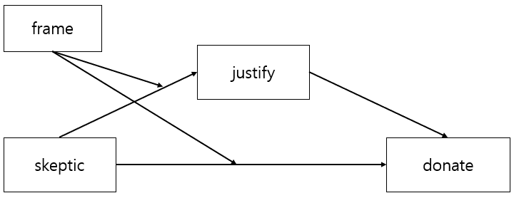

**Fig. (숫자)**

**Table1** Parameter estimates between skeptic and justify

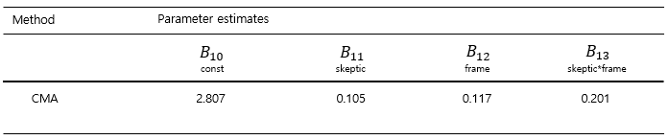

**Table2** Parameter estimates between skeptic + justify and donate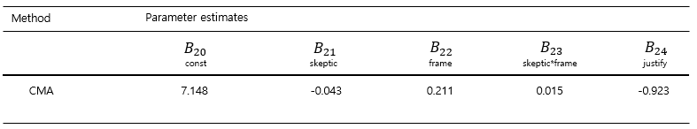

**Table3** Conditional effects of X and M on Y

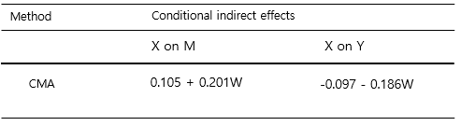

**Table4**

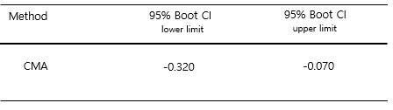

**4.2 Work-b Data**

This data was collected by authentic-happiness.com. Participants take an online survey to measure the work-life balance score. The "supporting" variable means the number of people that you have been helping for more than a year(0: None, 10: 10 people or more). The "donation" variable means how many times you donate your money or time more than a year(0: None, 5: 5 times or more). The “personal_awards” variable means how many achievements you are proud of in the past year.(0: None, 10: 10 achievements or more). The “wlbs” variable means the work-life balance score. The relation between these variables is shown in Fig.

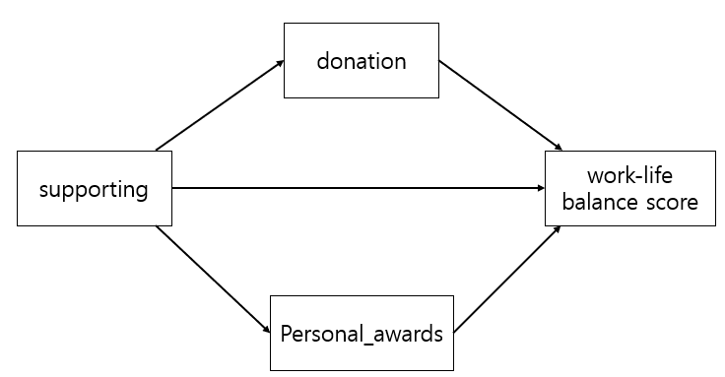

**Table1** Parameter estimates between supporting and donation

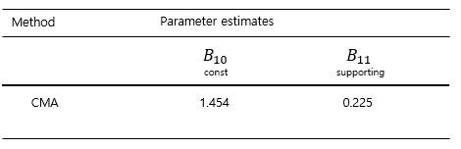

**Table2** Parameter estimates between supporting and personal_awards

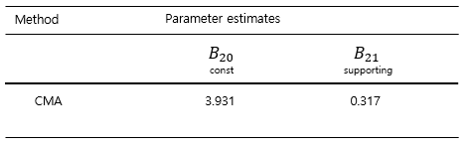

**Table3** Parameter estimates between supporting + donation + personal_awards and work-life balance score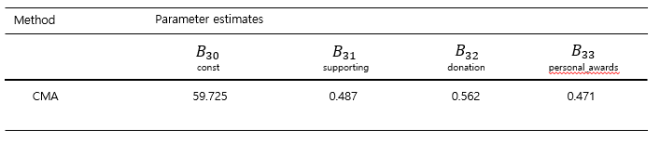

**Table4** Effects of the supporting on work-life balance score under donation and personal_awards

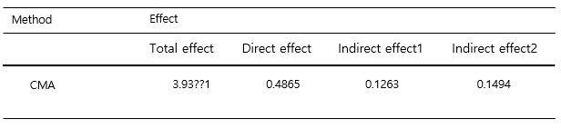

**Table5**

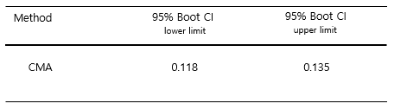

**Acknowledgement** This work was supported by the National Research Foundation of Korea(NRF) grant funded by the Korea government(MSIT) (No. 2020R1A2C1A01011131; No. 2019M3F2A1073179).

**References**

1. Kim, B., Jung, S., Kim, M., Kim, J., Lee, H., & Kim, S.: Solar Power Generation Forecasting based on LSTM considering Weather Conditions. Journal of Korean Institute of Intelligent Systems. **30**(1), 7-12 (2020)

2. Song, J., Jeong, Y., Lee, S.: Analysis of prediction model for solar power generation. JDC. **12**(3), 243-248 (2014)

3. Kwan, Y.: A Comparison of Solar Power Forecasting Models Using Meteorological Forecast Data. Master thesis of Chung-Ang Univ., South Korea (2017)

4. Kim, Y., Lee, S., Kim, H.: Prediction Method of Photovoltaic Power Generation Based on LSTM Using Weather Information. KICS. **44**(12), 2231-2238 (2019)

5. Lee, C., Ji, P.: Development of Daily PV Power Forecasting Models using ELM. KIEEP. **64**(3), 164-168 (2015)

6. Huang, R., Huang, T., Gadh, R. Li, N.: Solar generation prediction using the ARMA model in a laboratory-level micro-grid. 2012 IEEE Third International Conference on SmartGridComm. 528-533 (2012)

7. Atique, S., Noureen, S., Roy, V., Subburaj, S., Bayne, S., Macifie, J.: Forecasting of total daily solar energy generation using ARIMA: A case study. IEEE 9th Annual CCWC. 114-119 (2019)

8. Lee, H.: Use of the Moving Average of the Current Weather Data for the Solar Power Generation Amount Prediction. KMMS. **19**(8), 1530-1537 (2016)

9. Jeong, J., Tae, Y.: Comparison Analysis for Characteristic of Short-Term Power generation Forecasting models for Building Integrated photovoltaics. AIK. **36**(2), 665-666 (2016)

10. Lee, K., Kim, W.: Forecasting of 24_hours Ahead Photovoltaic Power Output Using Support Vector Regression. JKIIT. **14**(3), 175-183 (2016)

11. Jeong, J., Chae, Y.: Improvement for Forecasting of Photovoltaic Power Output using Real Time Weather Data based on Machine Learning. KSLES. **25**(1), 119-125 (2018)

12. Son, H., Kim, S., Jang, Y.: LSTM-based 24-Hour Solar Power Forecasting Model using Weather Forecast Data. KIISE Transactions on Computing Practices. **26**(10), 0435 ~ 0441 (2020)

13. Baron R.M., Kenny D.A.: The moderator-mediator variable distinction in social psychological research: conceptual, strategic, and statistical considerations. J Pers Soc Psychol. **51**(6), 1173-82 (1986)

14. Jung, S., Seo, D.: Assessing Mediated Moderation and Moderated Mediation : Guidelines and Empirical Illustration. Korean Journal of Psychology General. **35**(1), 257-282 (2016)

15. Kim, J.-E., Kim, J.-S.: A Study on the Mediating Effect of Self esteem in the Influence of Social Bonding of Youth on Self Leadership : A Multi-group Analysis between poverty perceptions adolescents of correctional facility and General Adolescents. Journal of Transactional Analysis & Counseling. **9**(1), 45-63 (2019)

16. Bak, S., Kim, H.: The Effects of Job-seeking stress on Somatization Symptoms in college students : The Mediating Effects of Maladaptive Self-focused Attention and Emotion Dysregulation. Journal of the Korea Convergence Society. **12**(6), 267-278 (2021)

17. Musić, J., Kružić, S., Stančić, I., Papić, V.: Adaptive Fuzzy Mediation for Multimodal Control of Mobile Robots in Navigation-Based Tasks. International Journal of Computational Intelligence Systems. **12**(2), 1197-1211 (2019)

18. Cole, M.-S., Walter, F., Bruch, H.: Affective Mechanisms Linking Dysfunctional Behavior to Performance in Work Teams: A Moderated Mediation Study. Journal of Applied Psychology. **93**(5), 945-958 (2008)

19. Lockhart, G., MacKinnon, D.-P., Ohlrich, V.: Mediation Anaysis in Psychosomatic Medicine Research. Psychosom Med. **73**(1), 29-43 (2011)

20. Stigler, M.H., Kugler, K.C., Komro, K.A., Leshabari, M.T., Klepp, K.I.: AIDS education for Tanzanian youth: a mediation anaysis. Health Education Research. **21**(4), 441-451 (2006)

21. Zadeh, L.A.: Fuzzy sets. Information and control. **8,** 338-353 (1965)

22. Yoon, J.-H.: Fuzzy mediation analysis. Int. J. Fuzzy Syst. **22**(1), 338-349 (2020)

23. Chung, I.-J., Kim, S.-D.: A Empirical Analysis on Government Evaluation and Trust in State Institutions of Participatory Government: Focusing on Mediating Effects of Subjective Class Identification. The korean Association for Public Society. **1**(2), 59-95 (2011)

24. Kim, J.-E., Kim, J.-S.: Journal of Transactional Analysis & Counseling, A Study on the Mediating Effect of Self esteem in the Influence of Social Bonding of Youth on Self Leadership : A Multi-group Analysis between poverty perceptions adolescents of correctional facility and General Adolescents. **9**(1), 45-63 (2019)

25. Bak, S.-G., Kim, H.-S.: The Effects of Job-seeking stress on Somatization Symptoms in college students: The Mediating Effects of Maladaptive Self-focused Attention and Emotion Dysregulation, Journal of the Korea Convergence Society. **12**(6), 267-278 (2021)

26. Yoon, J.-H.: Fuzzy Moderation and Moderated-Mediation Analysis. Int. J. Fuzzy Syst. **22**(1), 338-349 (2020)

27. Yoon, J.-H., Choi, S.-H.: Fuzzy least squares estimation with new fuzzy operations, Advances in Intelligent Systems and Computing. **190**, 193-202 (2013)

28. Yoon, J.-H., Choi, S.-H., Grzegorzewski, P.: On asymptotic properties of the multiple fuzzy least squares estimator. Soft Methods for Data Science. **456**, 525-532 (2016)

29. Yoon, J.-H., Grzegorzewski, P.: On optimal and asymptotic properties of a fuzzy L2 estimator. Mathematics. **8**, 1956 (2020)

30. [Hayes](https://journals.sagepub.com/doi/abs/10.1177/0956797613480187), A.F., [Scharkow](https://journals.sagepub.com/doi/abs/10.1177/0956797613480187), M.: The Relative Trustworthiness of Inferential Tests of the Indirect Effect in Statistical Mediation Analysis Does Method Really Matter?. Psychological Science. **24**, 1918-1927 (2013)

31. Sobel, M.E.: Asymptotic Confidence Intervals for Indirect Effects in Structural Equation Models. Sociological Methodology. **13**, 290-312 (1982)